APPENDIX 1

RASPBERRY PI BASED HOME AUTOMATION USING IOT

A MINOR PROJECT REPORT

Submitted by

PANTHAM SAI VIJAY ROHIT RA1511008010031
RISHI GAYATHRI .C RA1511008010147
SREYOSHEE LASKAR RA1511008010008
VEMULA KRISHNATEJA RA1511008010052

in partial fulfillment for the award of the degree

of

BACHELOR OF TECHNOLOGY

IN

INFORMATION TECHNOLOGY



SRM INSTITUTE OF SCIENCE AND TECHNOLOGY
KATTANKULATHUR

APRIL 2018

APPENDIX 2

SRM INSTITUTE OF SCIENCE AND TECHNOLOGY
KATTANKULATHUR

BONAFIDE CERTIFICATE

Certified that this project report “HOME AUTOMATION USING
RASPBERRY PI” is the bonafide work of
“PANTHAM SAI VIJAY ROHIT(RA1511008010031),
RISHI GAYATHRI .C(RA1511008010147),
VEMULA KRISHNATEJA(RA1511008010052) &
SREYOSHEE LASKAR(RA151108010008) ’’
who carried out the project work under my supervision.

SIGNATURE SIGNATURE

Ms.G.Geetha HEAD OF THE DEPARTMENT
Assistant Professor(OG) Information Technology
Information Technology

INTERNAL EXAMINER

DECLARATION

We PANTHAM SAI VIJAY ROHIT (RA1511008010031),
RISHI GAYATHRI .C(RA1511008010147),
VEMULA KRISHNATEJA(RA1511008010052) &
SREYOSHEE LASKAR(RA151108010008)
studying in III year B.Tech Information Technology program at, SRM Institute of
Science and Technology, Kattankulathur, Chennai, hereby declare that this project is
an original work of mine and I have not verbatim copied / duplicated any material
from sources like internet or from print media, excepting some vital company
information / statistics and data that is provided by the company itself.

Signature of the Student
Date:
Place:

ACKNOWLEDGEMENT

The success and the final outcome of this project required guidance and assistance from different sources and we feel extremely fortunate to have got this all along the completion of our project. Whatever we have done is largely due to such guidance and assistance and we would not forget to thank them.
We express our sincere thanks to the Head of the Department, Department of Information Technology, Dr.G.Vadivu, for all the help and infrastructure provided to us to complete this project successfully and his valuable guidance.
We owe our profound gratitude to our project guide MS. G. GEETHA, who took keen interest in our project work and guided us all along, till the completion of our project work by providing all the necessary information for developing a good system.
We are thankful to and fortunate enough to get constant encouragement, support and guidance from all the Teaching staff of the Department of Information Technology which helped us in successfully completing our minor project work. Also, we would like to extend our sincere regards to all the non-teaching staff of the department of Information Technology for their timely support.
Name and Reg. No .

ABSTRACT

This paper deals with the design and implementation of Raspberry pi based IOT
concept it means internet of things.

In this present generation everything is going on internet itself. So in this project we concentrate totally on the present generation. Life how they can get security to their
home or office and control the devices by using android app just by using internet in
their smart phones.

Raspberry pi acts like a small minicomputer it is totally a Linux platform. By just
connecting mouse and keyboard we can operate it as minicomputer where we can play
games, play videos etc. just like our personal laptop work. And also the WI-FI module
is used in this project to control the devices from remote location also by getting the
status of the devices into smart phone android app everything is going on internet
itself our day to day life. Future generation will work on internet itself by sitting in
one place we can do anything on internet.

Keywords: IOT, Wi-Fi, automation, Raspberry pi

APPENDIX 3

TABLE OF CONTENTS

CHAPTER NO. TITLE PAGE NO.

ABSTRACT 5

LIST OF FIGURES 8
LIST OF SYMBOLS, ABBREVIATIONS 9
AND NOMENCLATURE

1. INTRODUCTION 10
1.1 PROBLEM STATEMENT 12
1.2 LITERATURE SURVEY 13
1.3 HOME AUTOMATION 14
1.4 INTERNET OF THINGS 15

2. REQUIREMENT ANALYSIS 16
2.1 REQUIRED COMPONENTS &MATERIAL 16
2.1.1 FUNCTIONAL REQUIREMENT
2.1.1.1 WIFI MODULE
2.1.1.2 RASPBERRY PI
2.2 NON FUNCTIONAL REQUIREMENT 18
2.2.1 RELAY
2.3 HARDWARE COMPONENTS 21
2.4 SOFTWARE COMPONENTS 22

3. DESIGN 28

4. MODULES 29

4.1 FIRST MODULE 29

4.1.1 REQUIREMENT ANALYSIS

4.2 SECOND MODULE 29

4.2.1 DESIGN AND IMPLEMENTATION
4.3 THIRD MODULE 30
4.3.1 ANALYSIS AND TESTING
5. IMPLEMENTATION 31
5.1 PUBLIC IP 31

5.2 PYTHON CODE 33

5.2.1 ON.PY
5.2.2 OFF.PY
5.3 CSS CODE 34
5.3.1 STYLE.CSS
5.4 INDEX.PHP 35

6. TESTING 40

7. APPLICATIONS 46

8. CONCLUSION 47

9. REFERENCES 48

LIST OF FIGURES
NAME PAGE.NO

Fig1 SYSTEM DESIGN-------------------------------------------------------------- 11
Fig2 IOT------------------------------------------------------------------------------- 15
Fig3 RASPBERRY PI BOARD--------------------------------------------------- 17
Fig4 RELAY MODULE------------------------------------------------------------- 18
Fig5. SYSTEM ARCHITECTURE----------------------------------------------- 21
Fig6. CONCEPT OF PUBLIC IP-------------------------------------------------- 22
Fig7. WEB INTERFACE OF THE CONTROL SYSTEM -------------------- 28
Fig8. RASPBIAN CODE ----------------------------------------------------------- 28

LIST OF SYMBOLS, ABBREVIATIONS AND NOMENCLATURE

- VPC-Virtual Private Cloud
- IOT-Internet Of Things
- GPIO-General Purpose Input/Output
- NC-Normally Closed
- NO-Normally Opened
- COM-Common
- WFI-Wait For Interrupt
- SD-Secure Digital
- HVAC-Heating Ventilation and Air Conditioning
- DTMF-Dual Tone Multi Frequency
- GUI-Graphical User Interface

1.INTRODUCTION

The project focuses on controlling the Electronic Devices with a Remote or a Smartphone. The major focus of this project is to provide the Ease of Access to handicapped people. A Live Monitoring System to get the fresh updates of what exactly the power consumption of a Room or a Hall is happening.

If you are outside, you can check the temperature of your Home and according to it, you can turn on the AC from the website. We will provide an Easy and reliable GUI for the user so that anyone can learn it easily. It will also consist of User Authentication with an Administrative feature to handle the number of users and the Admin can grant access to some home appliances to a particular user.

Our Future is in our Hand so let’s make it better and advanced. In this world of technology, we all have a very busy life and one can think of living in a comfort zone rather than getting it stressed. So why cannot we use technology to make things better. Home Automation is the first approach to this, which has become and will become a trend in 21st and the upcoming century.

Home Automation is a term used to describe the working of all household amenities and appliances together and we are making it control from our daily use or things
especially smartphones, tablets or a computer having Internet connectivity. Mobile's
smartphones and laptops are the means from which one can use the Internet at any time and from anywhere. So, if we will open a door that connects you to your various daily home appliances then we can control our home.

Many companies like Samsung, Control4, Crestron, AMX, ELAN Home Systems etc. are working for this system and to make it intelligent enough so that the system can communicate with humans which will be no longer far.
There are many projects regarding this topic using DTMF based, JAVA based, Android-based, Wi-Fi based, Bluetooth-based or by using Arduino UNO etc.

A custom-made Raspberry Pi will be fitted at each power points or switch boards. It will act as the control for all electrical appliances (lighting, fans, air conditioners etc).There will be no work for the user regarding his/her appliance. One has to initialize the required settings at the time of setting up of the system. After that the system will be individual and self-sustained. The custom Raspberry Pi will have relays fixed on, which will control all lighting and fans or any other electrical appliances.

This board will have a Wireless connection that connects to an Internet hub. This Internet hub will be connected to the internet via LAN or Wi-Fi (Depends upon the choice of the user). As mentioned earlier the internet acts as a master since the entire control process is taken care of by an online server-side program (ASP or PHP modules).

The web-page will be coded in such a way that it provides complete control to the user over the automation process such as timing and conditions for the automation process.

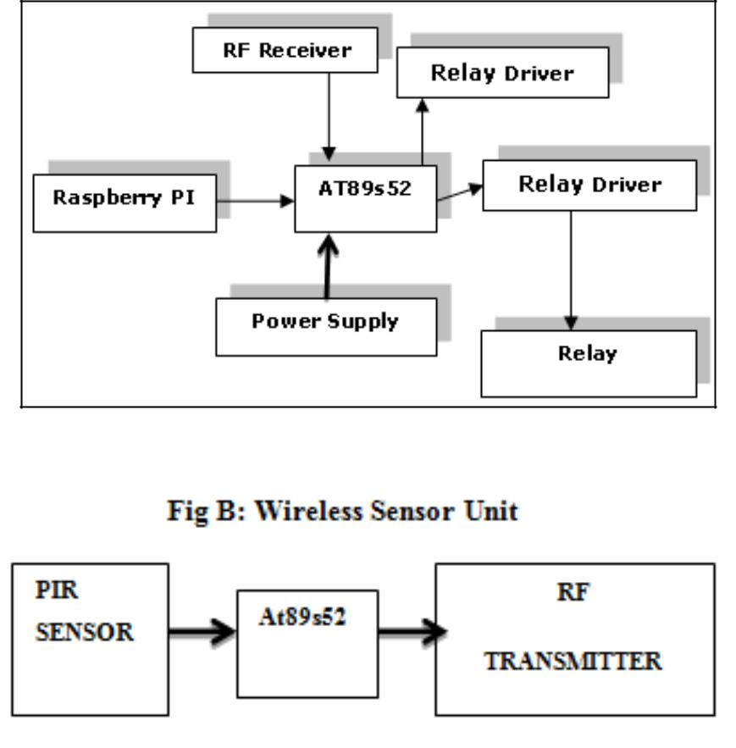
Figure 1: System design

  - PROBLEM STATEMENT

Home automation is building automation for a home, called a smart home or smart
house. It involves the control and automation of lighting, heating (such as smart
thermostats), ventilation, air conditioning (HVAC) and security, as well as home
appliances such as washer/dryers, ovens or refrigerators/freezers. Wi-Fi is often used
for remote monitoring and control. Home devices, when remotely monitored and
controlled via the Internet, are an important constituent of the Internet of Things.

Modern systems generally consist of switches and sensors connected to a central hub
sometimes called a "gateway" from which the system is controlled with a user
interface that is interacted either with a wall-mounted terminal, mobile phone
software, tablet computer or a web interface, often but not always via Internet cloud
services.

While there are many competing vendors, there are very few worldwide accepted
industry standards and the smart home space is heavily fragmented. Manufacturers
often prevent independent implementations by withholding documentation and by
litigation.

The focus of our project is on helping users to operate home appliances with their own
smartphones and to help elderly or handicapped people live a more independent life as
long as possible. The objective of our system is to take care of several domestic
systems that may normally be difficult for those who are handicap or elderly to take
care of. This application will allow the user to control a device that is connected to any
home appliance that is Pi enabled.

1.2 LITERATURE SURVEY

This paper provides a simple introduction to the IoT, its application and potential
benefits to the society [4]. IoT has received much attention from scientists, industry
and government all over the world for its potential in changing modern day living.

IoT is envisioned as billions of sensors connected to the internet through wireless and
other communication technologies. The sensors would generate large amount of data
which needs to be analysed, interpreted and utilized [3].

Home Automation System uses the technology of Internet of Things for monitoring
and controlling of the electrical and electronic appliances at home from any remote
location by simply using a Smartphone. Implementation of a low cost, flexible home
automation system is presented. It enhances the use of wireless communication which
provides the user with remote control of various electronic and electrical appliances
[1].

1.3 HOME AUTOMATION
In 19th century, concept of home automation came into the picture. The Electronic Computing Home Operator was developed in the April 1968 and has been enhanced from a set of spare electronics. Further X10 standard was developed to allow transmitters and receivers to broadcasting messages such as “turn ON” and “turn OFF” via radio frequency. X10 system has number of disadvantages.
With the invention of the Raspberry pi which is small credit card size computer having large number of peripherals along with communication ports like Ethernet, USB ports, HDMI port, now a day’s home automation is become very easy and interesting.
Home automation includes all that a building automation provides like door and window controls, climate controls, control of multimedia home theatres, pet feeding, plant watering and so on. Home automation is nothing but ‘Smart home’ or ‘Intelligent home’. Such smart homes or intelligent homes are controlled with the help of various technologies. GSM, WIFI, Bluetooth, Zig bee and so on are used for the purpose of home automation.

1.4 INTERNET OF THINGS

The IoT allows objects to be sensed and controlled remotely across existing network
infrastructure, creating opportunities for more direct integration of the physical world
into computer-based systems, and resulting in improved efficiency, accuracy and
economic benefit.

The Internet of Things is the network of physical objects devices, vehicles, buildings
and other items embedded with electronics, software, sensors, and network
connectivity that enable these objects to collect and exchange data. The IoT allows
objects to be sensed and controlled remotely across existing network infrastructure.
The concept of the Internet of Things first became popular in 1999, through at MIT
and related market analysis publication

Integration with the internet implies that devices will use the IP address as a unique
identifier. due to the limited address space of IPv4 (which allows for 4.3 billion
unique addresses), objects in the IoT will have to use IPv6 to accommodate the
extremely large address space required.

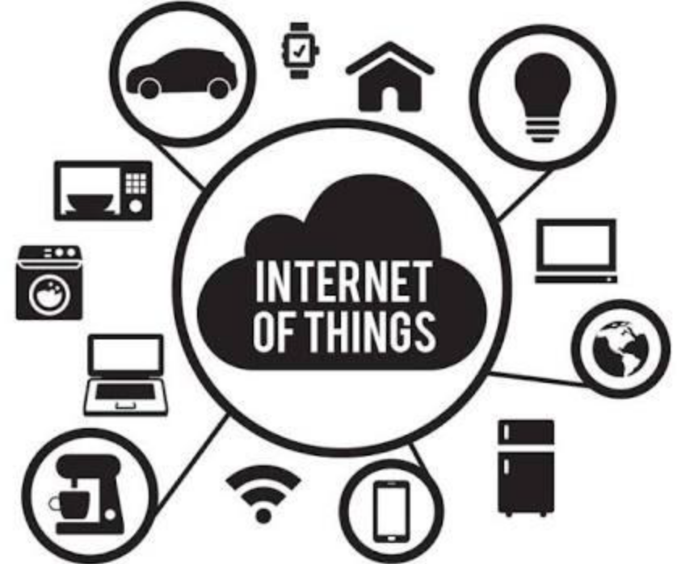
Figure 2: IoT

2. REQUIREMENT ANALYSIS WORK

2.1 Required components & materials:

2.1.1 Functional:
The essential components and materials for home automation using IoT can be listed
as a Wi-Fi module, Raspberry pi 2 model B.

2.1.1.1 Wi-fi module:
Wi-fi (wireless fidelity) is a wireless networking technology used for exchanging the
information between two or more devices without using cables or wires. There are
various wi-fi technologies like wi-fi 802.11a, 802.11b, 802.11g and 802.11n. Here, in
this project wi-fi module is used to receive commands from the internet and activate
loads through triac & optocoupler by executing a program written within the wi-fi
module. Hence, no microcontroller is used in this project to drive loads.

      - Raspberry Pi
The Raspberry Pi is a series of credit card–sized singleboard computers developed in
the United Kingdom by the Raspberry Pi Foundation with the intention of promoting
the teaching of basic computer science. They develop free resources to help people
learn about computing and how to make things with computers. Raspberry Pi’s
inception began in 2006. Two models were announced in 19 February 2012: Model A
and Model B. Model B+ was announced in July 2014. Pi 3 Model B is announced on
29th February 2016 [4]. Raspberry pi is low cost minicomputer. It is possible to
connect Monitor of PC as well as television to the Raspberry pi. Mouse and Keyboard
can be connected to the Raspberry pi. All models having a Broadcom system on a
chip, it includes an ARM compatible central processing unit (CPU) and an on-chip
graphics processing unit. CPU speed ranges from 700 MHz to 1.2 GHz for the Pi 3.
On board memory range from 256 MB to 1 GB RAM. Secure Digital (SD) cards are
used to store the operating system and program memory. Most of the Raspberry pi
board are having USB ports, HDMI post, DSI port, Audio jack, 40 GPIO pins, In-built
Bluetooth, WIFI and so on.

Raspberry pi is having its own operating system. Raspbian, Ubuntu mate, snappy
Ubuntu, Pidora, Linutop, Arch Linux ARM and so on are the various operating
systems used for the Raspberry pi. Raspberry pi supports different programming
languages like C++, Python, SQL, and HTSQL. C++ uses for programming
Arduino.HTSQL (Hyper Text Structured Query Language) to provide a web interface
to database that is easy to query via the web browser. It also supports java, java script,
php and so on.

The Raspberry Pi has four distinct power modes [6]:

- The run mode – the central processing unit (CPU) and all functionality of the ARM11 core are available and powered up.
- The standby mode – the main core clocks are shut down (the parts of the CPU
that process instructions are no longer running) although the power circuits on the core are still active. In this mode, known as ‘‘Wait for Interrupt’’ (WFI) mode, the core can be quickly woken up by a process generating a special call to the CPU called an interrupt. This interrupt will stop any current processing and do what the calling process has asked for.
- The shutdown mode – there is no power.
- The dormant mode – the core is powered down and all caches are left powered on.

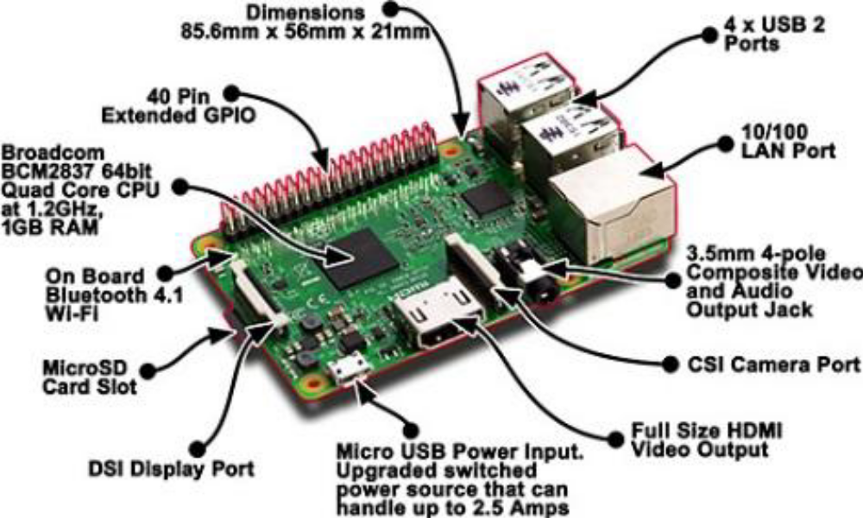

Figure 3: Raspberry pi board

2.2 Non-Functional:

Relay board,
gpio,
loads (home appliances).

2.2.1 Relay
Relay is nothing but it is the electromagnetic switch. Relay allows one circuit to
switch another circuit while they are separated. Relay is used when we want to use a
low voltage circuit to turn ON and OFF the device which required high voltage for its
operation. For example, 5V supply connected to the relay is sufficient to drive the
bulb operated on 230V AC mains. Relays are available in various configurations of
operating voltages like 6V, 9V, 12V, 24V and so on. Relay is divided into two parts,
one is input and other is output. Input side is nothing but a coil which generate
magnetic field when small input voltage is given to it.

Relay having three contactors: Normally closed (NC), Normally opened (NO) and
common (COM). By using the proper combinations of the contactors electrical
appliances may turn ON or OFF.

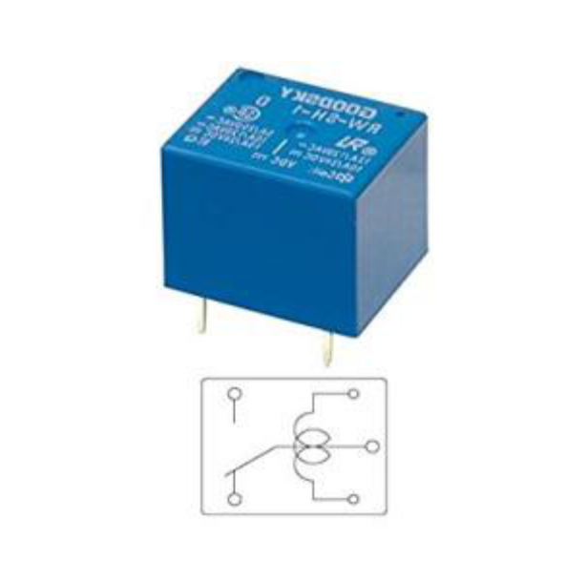

Figure 4: Relay module

2.2.2 GPIO:

General-purpose input/output (GPIO) is a generic pin on an integrated circuit or computer board whose behavior—including whether it is an input or output pin—is controllable by the user at run time.

GPIO pins have no predefined purpose, and go unused by default.^{[1][2]} The idea is that sometimes a system integrator who is building a full system might need a handful of additional digital control lines—and having these available from a chip avoids having to arrange additional circuitry to provide them. For example, the Realtek ALC260 chips (audio codec) have 8 GPIO pins, which go unused by default. Some system integrators (Acer Inc. laptops) use the first GPIO (GPIO_0) on the ALC260 to turn on the amplifier for the laptop's internal speakers and external headphone jack.

GPIO capabilities may include:
- GPIO pins can be configured to be input or output
- GPIO pins can be enabled/disabled
- Input values are readable (typically high or low)
- Output values are writable/readable
- Input values can often be used as IRQs (typically for wakeup events)

GPIO peripherals vary widely. In some cases, they are simple—a group of pins that can switch as a group to either input or output. In others, each pin can be set up to accept or source different logic voltages, with configurable drive strengths and pull ups/downs.
Input and output voltages are typically—though not always—limited to the supply voltage of the device with the GPIOs, and may be damaged by greater voltages.
A GPIO pin's state may be exposed to the software developer through one of a number of different interfaces, such as a memory mapped peripheral, or through dedicated IO port instructions.
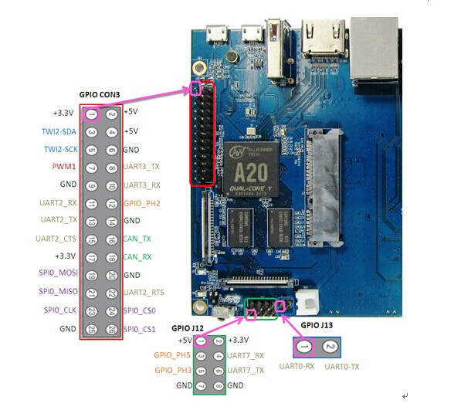
Figure 5 : GPIO PINS
Some GPIOs have 5 V tolerant inputs: even when the device has a low supply voltage (such as 2 V), the device can accept 5 V without damage. A GPIO port is a group of GPIO pins (typically 8 GPIO pins) arranged in a group and controlled as a group.^{[4]}

2.3 Hardware Components:

Raspberry Pi,
Personal Computer,
Male Jumper,
Modem,
Female jumper.

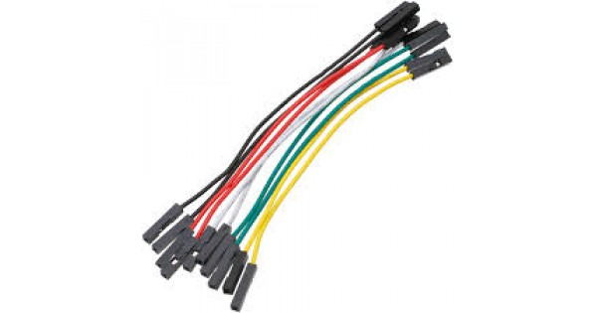

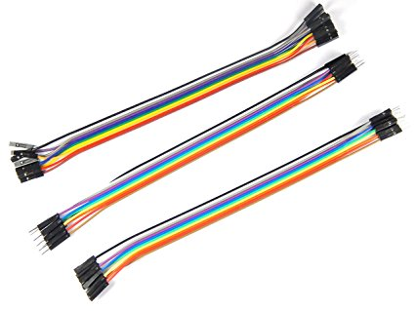

Figure :Jumper Cables.

2.4 Software Components:

Raspbian Operating System,
Python IDLE, Sublime Text (HTML,PHP,CSS) ,
MATPLOT Library,
Numpy,
RPi Package,
Web Hosting,
GPIO modules.

- Python:

Python is an interpreter, interactive, object-oriented programming language. It in corporates modules, exceptions, dynamic typing, very high level dynamic data types,and classes. Python combines remarkable power with very clear syntax. It hasinterfaces too many system calls and libraries, as well as to various window systems,and is extensible in C or C++. It is also usable as an extension language for applications that need a programmable interface. Python is a high-level general purpose programming language that can be applied to many different classes of problems.

- Raspbian:

Is a free Operating System based on Debian. Optimized for the raspberry pi hardware. Raspbian comes with more than 35000 packages; pre-combined software bundled in a nice format for easy installation on Raspberry pi.
There are several versions of Raspbian including Raspbian Stretch and Raspbian Jessie. Since 2015 it has been officially provided by the Raspberry Pi Foundation as the primary operating system for the family of Raspberry Pi single-board computers.
Raspbian was created by Mike Thompson and Peter Green as an independent project. The initial build was completed in June 2012. The operating system is still under active development. Raspbian is highly optimized for the Raspberry Pi line's low-performance ARM CPUs.
Raspbian uses PIXEL, Pi Improved Xwindows Environment, Lightweight as its main desktop environment as of the latest update.
It is composed of modified LXDE desktop environment and the Openbox stacking window manager with a new theme and few other changes.
The distribution is shipped with a copy of computer algebra program Mathematica and a version of Minecraft called Minecraft Pi as well as a lightweight version of Chromium as of the latest version.
C. Web Hosting

A web hosting service is a type of Internet hosting service that allows individuals and organizations to make their website accessible via the World Wide Web. Web hosts are companies that provide space on a server owned or leased for use by clients, as well as providing Internet connectivity, typically in a data center. Web hosts can also provide data center space and connectivity to the Internet for other servers located in their data center, called colocation, also known as Housing in Latin America or France.

Host:
The host may also provide an interface or control panel for managing the Web server and installing scripts, as well as other modules and service applications like e-mail. A web server that does not use a control panel for managing the hosting account, is often referred to as a "headless" server. Some hosts specialize in certain software or services (e.g. e-commerce, blogs, etc.).

Reliability and uptime:
The availability of a website is measured by the percentage of a year in which the website is publicly accessible and reachable via the Internet. This is different from measuring the uptime of a system. Uptime refers to the system itself being online. Uptime does not take into account being able to reach it as in the event of a network outage. A hosting provider’s Service Level Agreement (SLA) may include a certain amount of scheduled downtime per year in order to perform maintenance on the systems. This scheduled downtime is often excluded from the SLA timeframe, and needs to be subtracted from the Total Time when availability is calculated. Depending on the wording of an SLA, if the availability of a system drops below that in the signed SLA, a hosting provider often will provide a partial refund for time lost. How downtime is determined changes from provider to provider, therefore reading the SLA is imperative. Not all providers release uptime statistics. Most hosting providers will guarantee at least 99.9% uptime which will allow for 43m of downtime per month, or 8h 45m of downtime per year.

DNS:

The Domain Name System (DNS) is a hierarchical decentralized naming system for computers, services, or other resources connected to the Internet or a private network. It associates various information with domain names assigned to each of the participating entities. Most prominently, it translates more readily memorized domain names to the numerical IP addresses needed for locating and identifying computer services and devices with the underlying network protocols. By providing a worldwide, distributed directory service, the Domain Name System is an essential component of the functionality on the Internet that has been in use since 1985.
The Domain Name System delegates the responsibility of assigning domain names and mapping those names to Internet resources by designating authoritative name servers for each domain.
Network administrators may delegate authority over sub-domains of their allocated name space to other name servers. This mechanism provides distributed and fault tolerant service and was designed to avoid a single large central database.
The Domain Name System also specifies the technical functionality of the database service that is at its core. It defines the DNS protocol, a detailed specification of the data structures and data communication exchanges used in the DNS, as part of the Internet Protocol Suite. Historically, other directory services preceding DNS were not scalable to large or global directories as they were originally based on text files, prominently the hosts file.
The Internet maintains two principal namespaces, the domain name hierarchy and the Internet Protocol (IP) address spaces. The Domain Name System maintains the domain name hierarchy and provides translation services between it and the address spaces.
Internet name servers and a communication protocol implement the Domain Name System. A DNS name server is a server that stores the DNS records for a domain; a DNS name server responds with answers to queries against its database.
The most common types of records stored in the DNS database are for Start of Authority (SOA), IP addresses (A and AAAA), SMTP mail exchangers (MX), name servers (NS), pointers for reverse DNS lookups (PTR), and domain name aliases (CNAME).
Although not intended to be a general purpose database, DNS can store records for oth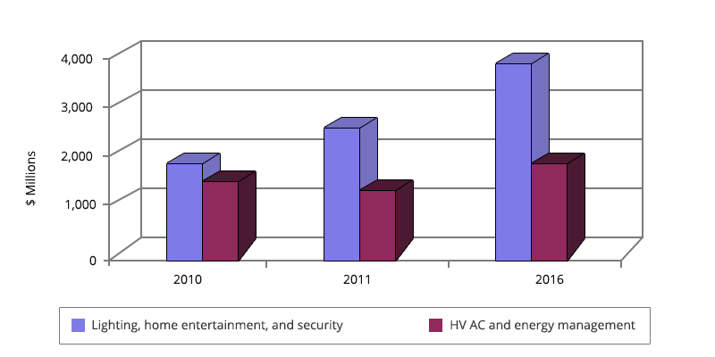er types of data for either automatic lookups, such as DNSSECrecords, or for human queries such as responsible person (RP) records.
As a general purpose database, the DNS has also been used in combating unsolicited email (spam) by storing a real-time blackhole list. The DNS database is traditionally stored in a structured zone file.

D.Numpy:

It is a library for the Python programming language, adding support for large, multi-dimensional arrays and matrices, along with a large collection of high-level mathematical functions to operate on these arrays. The ancestor of NumPy, Numeric, was originally created by Jim Hugunin with contributions from several other developers. In 2005, Travis Oliphant created NumPy by incorporating features of the competing Numarray into Numeric, with extensive modifications. NumPy is open-source software and has many contributors.

NumPy targets the CPython reference implementation of Python, which is a non-optimizing bytecode interpreter. Mathematical algorithms written for this version of Python often run much slower than compiledequivalents. NumPy addresses the slowness problem partly by providing multidimensional arrays and functions and operators that operate efficiently on arrays, requiring rewriting some code, mostly inner loops using NumPy.
Using NumPy in Python gives functionality comparable to MATLAB since they are both interpreted, and they both allow the user to write fast programs as long as most operations work on arrays or matrices instead of scalars. In comparison, MATLAB boasts a large number of additional toolboxes, notably Simulink, whereas NumPy is intrinsically integrated with Python, a more modern and complete programming language.
Moreover, complementary Python packages are available; SciPy is a library that adds more MATLAB-like functionality and Matplotlib is a plotting package that provides MATLAB-like plotting functionality. Internally, both MATLAB and NumPy rely on BLAS and LAPACK for efficient linear algebra computations.
Python bindings of the widely used computer vision library OpenCV utilize NumPy arrays to store and operate on data. Since images with multiple channels are simply represented as three-dimensional arrays, indexing, slicing or masking with other arrays are very efficient ways to access specific pixels of an image. The NumPy array as universal data structure in OpenCV for images, extracted feature points, filter kernels and many more vastly simplifies the programming workflow and debugging.

E. Modem:

A modem (modulator–demodulator) is a network hardware device that modulates one or more carrier wave signals to encode digital information for transmission and demodulates signals to decode the transmitted information.
The goal is to produce a signal that can be transmitted easily and decoded to reproduce the original digital data. Modems can be used with any means of transmitting analog signals, from light-emitting diodes to radio.
A common type of modem is one that turns the digital data of a computer into modulated electrical signal for transmission over telephone lines and demodulated by another modem at the receiver side to recover the digital data.
Modems are generally classified by the maximum amount of data they can send in a given unit of time, usually expressed in bits per second (symbol bit(s), sometimes abbreviated "bps"), or bytes per second (symbol B(s)). Modems can also be classified by their symbol rate, measured in baud.
The baud unit denotes symbols per second, or the number of times per second the modem sends a new signal. For example, the ITU V.21 standard used audio frequency-shift keying with two possible frequencies, corresponding to two distinct symbols (or one bit per symbol), to carry 300 bits per second using 300 baud.

By contrast, the original ITU V.22 standard, which could transmit and receive four distinct symbols (two bits per symbol), transmitted 1,200 bits by sending 600 symbols per second (600 baud) using phase-shift keying.
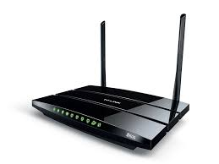
Figure 6: Modem

3. DESIGN

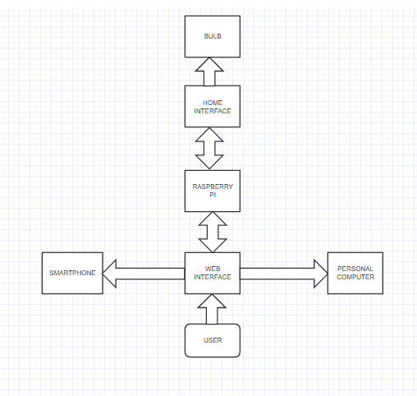

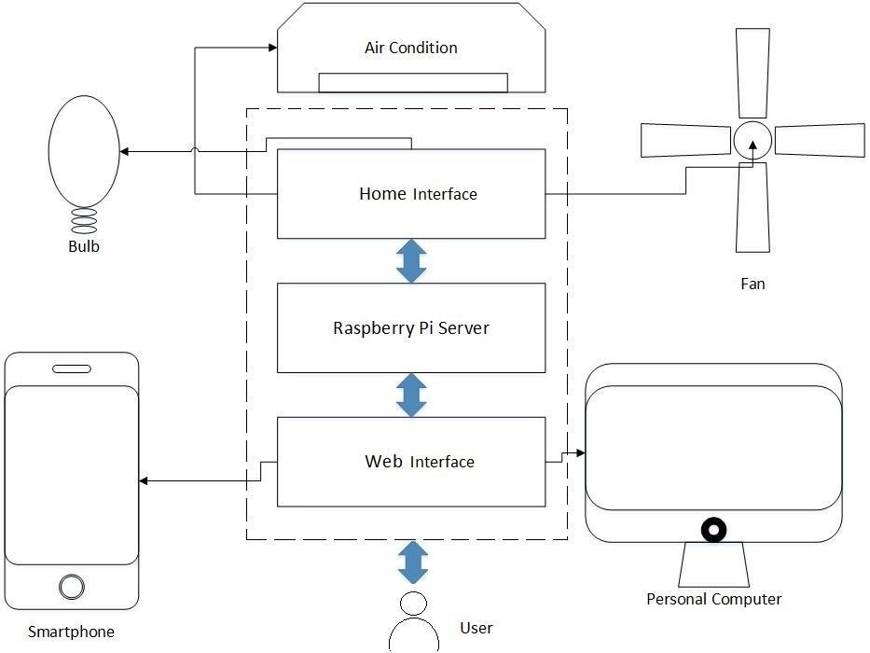
Figure : System design flowchart

4. MODULES
We have divided our project into three modules. These models will help us to update and improvise the project after each review. Our modules are segregated such that it could be easily comprehendible.

3.1 First Module:

3.1.1 Requirment Analysis:
- This module includes all the prior research required for developing the project.
- We study about IoT, working on raspberry pi, and python programming. since these are the basic requirements of our project.
- We are also getting the basicities ready like the gpio pins, wiring, microprocessor programming and other led lights, wifi module.

3.2 Second Module:

3.2.1 Design and Implementation:
- Setting up of the Raspberry Pi
- Implementing the working of the Raspberry Pi
- Developing the working environment: refer to the block diagram
- Creating platform for python code development

3.3 Third Module:

3.3.1 Analysis and Testing:
- Necessary coding to execute the functions for operating the system and finally checking for all the testcases.
- Understanding the drawbacks of the project, if any, re-improvise the code with necessary changes.
- Updating the testcases. Creating the final report of the project and submission.

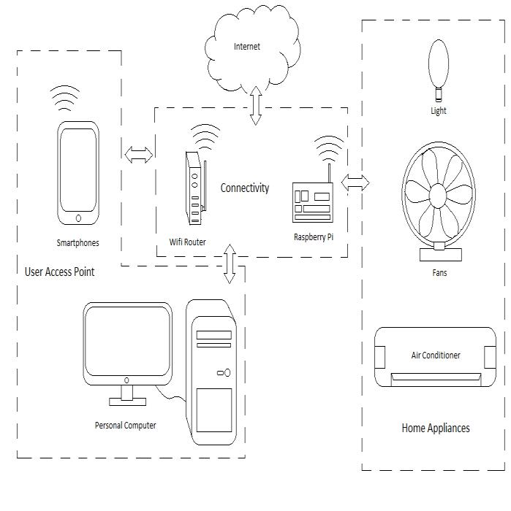

Figure 7: System Architecture

5. IMPLEMENTATION

5.1 PUBLIC IP:

Using home networks public IP and router we can remotely access raspberry pi's web server and control over appliances. Thus our motive for remote home access is accomplished.

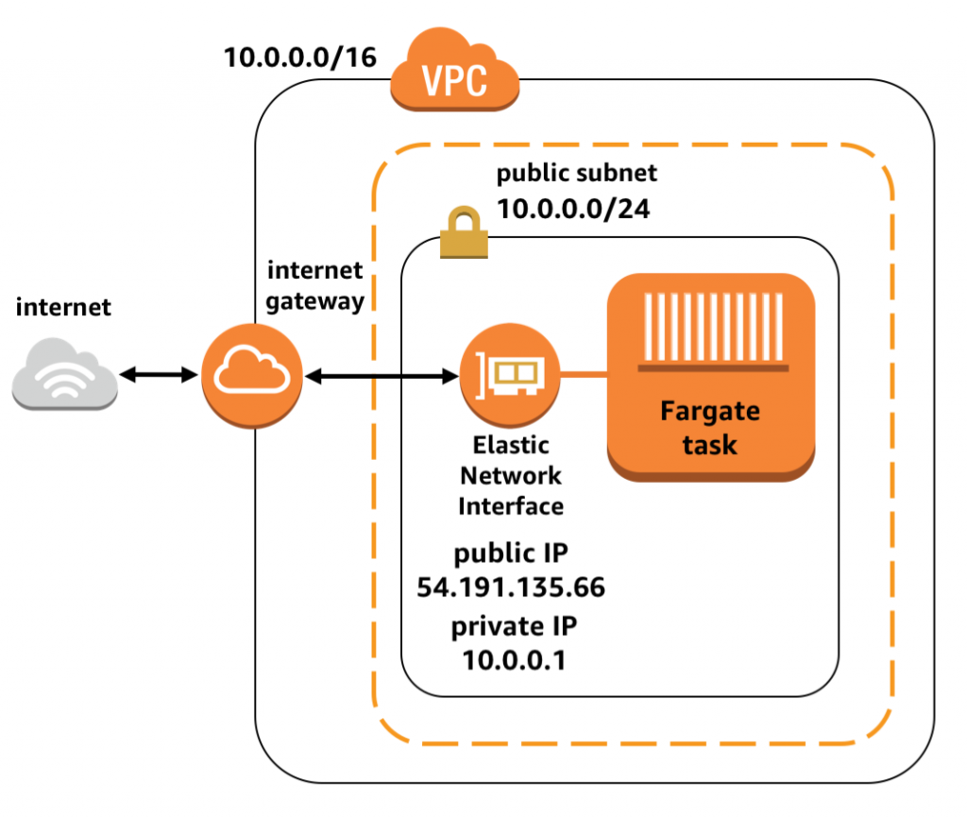
Figure 8: Concept of Public IP

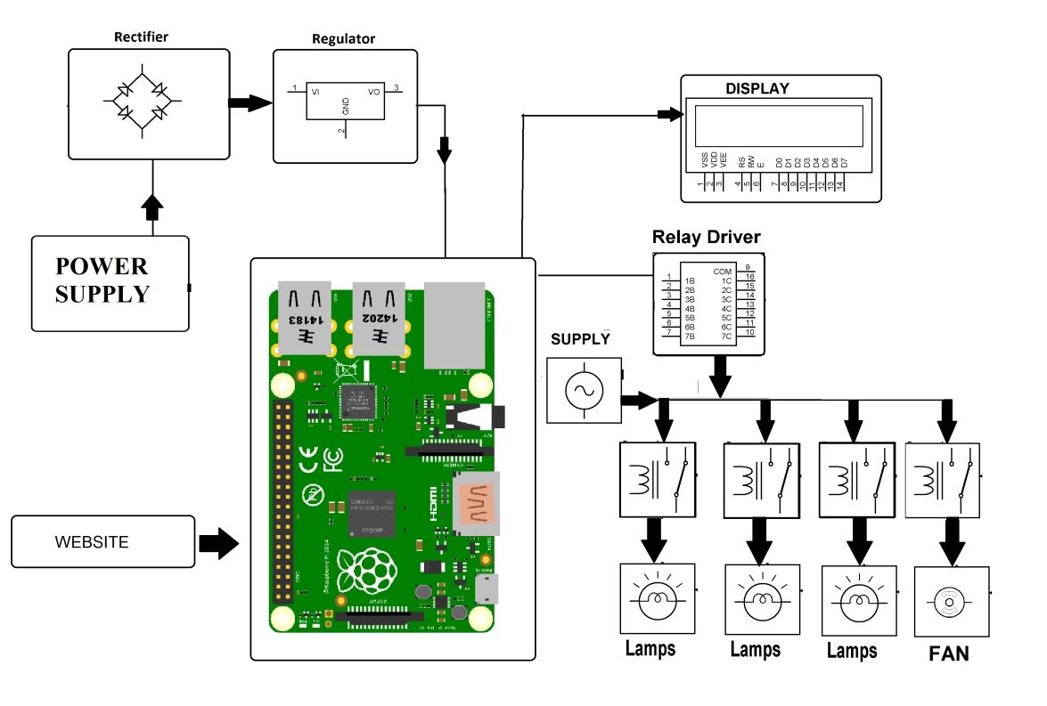

Figure 9: System structure
5.2 PYTHON CODE:

5.2.1 ON.PY:

import RPi.GPIO as GPIO
GPIO.setmode(GPIO.BCM)
GPIO.setup(2,GPIO.OUT)
GPIO.output(2,False)

5.2.2 OFF.PY:

import RPi.GPIO as GPIO
GPIO.setmode(GPIO.BCM)
GPIO.setup(2,GPIO.OUT)
GPIO.output(2,True)

5.3 CSS CODE:

5.3.1 STYLE.CSS

#content{
text-align:center;
position:relative;
right:-650px;
}
body{
font-family: 'Josefin Sans', sans-serif;
}

5.4 Index.php:

<html>

<head>
<title>Minor Project</title>
<link type="text/css" rel="stylesheet" href="style.css">
<link href="https://fonts.googleapis.com/css?family=Josefin+Sans" rel="stylesheet">
</head>

<body>
<div style="text-align:center; background-color:#39598c; padding:60px;">
<h1 style="color:white;">Home Automation with Raspberry Pi</h1>
</div>
<div>
<?php
if (isset($_POST['on1']))
{
exec("sudo python /var/www/html/light/on.py");
}
if (isset($_POST['on2']))
{
exec("sudo python /var/www/html/light/on2.py");
}
if (isset($_POST['on3']))
{
exec("sudo python /var/www/html/light/on3.py");
}
if (isset($_POST['on4']))
{
exec("sudo python /var/www/html/light/on4.py");
}
if (isset($_POST['off1']))
{
exec("sudo python /var/www/html/light/off.py");
}
if (isset($_POST['off2']))
{
exec("sudo python /var/www/html/light/off2.py");
}
if (isset($_POST['off3']))
{
exec("sudo python /var/www/html/light/off3.py");
}
if (isset($_POST['off4']))
{
exec("sudo python /var/www/html/light/off4.py");
}
?>
<form method="POST" action="">
<div>
<table id="content">
<tr>
<td>
<br>
<h3>Switch 1</h3>
<button style="background-color:GREEN;border:none;font-size:40;color:white;" name="on1">ON</button>
<button style="background-color:RED;border:none;font-size:40;color:white;" name="off1">OFF</button>
</td>
</tr>
<tr>
<td>
<br>
<h3>Switch 2</h3>
<button style="background-color:GREEN;border:none;font-size:40;color:white;" name="on2">ON</button>
<button style="background-color:RED;border:none;font-size:40;color:white;" name="off2">OFF</button>
</td>
</tr>
<tr>
<td>
<br>
<h3>Switch 3</h3>
<button style="background-color:GREEN;border:none;font-size:40;color:white;" name="on3">ON</button>
<button style="background-color:RED;border:none;font-size:40;color:white;" name="off3">OFF</button>
</td>
</tr>
<tr>
<td>
<br>
<h3>Switch 4</h3>
<button style="background-color:GREEN;border:none;font-size:40;color:white;" name="on4">ON</button>
<button style="background-color:RED;border:none;font-size:40;color:white;" name="off4">OFF</button>
</td>
</tr>
</table>
</div>
</form>
</div>
</body>

</html>

5.5 Raspberry Web Server
First, we will install Apache, which is the web server as such.
When we speak of a web server, we often think about the machine, but this term also refers to the software that allows the machine to analyze user requests (in http form), and to return the file corresponding to the request (Or an error if the file isn’t found, or the query incorrectly formulated). As part of Apache, it’s software that we talk about.

At the moment, Apache is the most used web server, with about 60% market share. Apache has its own license, used by many other projects. In addition, the massive use of Apache (which has become the standard for web servers), coupled with its high popularity, has led to a tremendous abundance of documentation, courses, and other books dealing with its use, and his security, like this book.
Whether it is for the Raspberry Pi and Raspbian, or for a more general-purpose machine, Apache is therefore a safe choice, and the skills you will be able to acquire on the subject will always be useful.

Apache installation
Before installing the server, make sure we have an up-to-date machine. To do this we must have administrator rights, either because of the sudo command.
sudo apt update
sudo apt upgrade
sudo apt update
Once the Raspberry Pi is up to date, we will install the Apache server.
sudo apt install apache2
By the way, we’ll take advantage of it to give rights to the apache file that you can easily manage your sites. To do this, run the following commands:
sudo chown -R pi:www-data /var/www/html/
sudo chmod -R 770 /var/www/html/

Check if Apache is working
Once the installation completed, we can test that Apache is working properly by going to the Raspberry address. To do this, it’s necessary to try to access to the Raspberry from port 80 (this port not being opened from the outside, it will have to do since the Raspberry itself). Do not worry, it’s very easy. Simply open the Raspberry web browser, and go to “http://127.0.0.1”. You should then get a page with a message like “It works! “And plenty of other text. If you do not already have a GUI on your Raspbian, or you use SSH to connect to your Raspberry, you can use the following command:
wget -O check_apache.html http://127.0.0.1
This command will save the HTML code of the page in the file “check_apache.html” in the current directory. So you only have to read the file with the command
cat ./check_apache.html
If you see marked at a location in the code “It works! ” is that Apache is working.
Apache uses the directory “/var/www/html” as the root for your site. This means that when you call your Raspberry on port 80 (http), Apache looks for the file in “/var/www/html”.
For example, if you call the address “http://127.0.0.1/example”, Apache will look for the “example” file in the “/var/www/html” directory. To add new files, sites, etc., you will need to add them to this directory.
You can now use your Raspberry to make a site in HTML, CSS and JavaScript, internally.
However, you may want to quickly allow interactions between the site and the user. For example, to allow the user to register, etc. For this, you are going to need PHP.

PHP INSTALLATION:
We will again use the administrator to install PHP with the command line.
sudo apt install php php-mbstring

Control if PHP is working

To know if PHP is working properly, it’s not very complicated, and the method is quite similar to the one used for Apache.

You will first delete the file “index.html” in the directory “/var/www/html”.
sudo rm /var/www/html/index.html
Then create an “index.php” file in this directory, with this command line
echo "<?php phpinfo ();?>" > /var/www/html/index.php
From there, the operation is the same as for the Apache check. You try to access your page, and you should have a result close to this image (if you do not have an interface, use the same method as before, and look for the words “PHP Version”).

6. TESTING

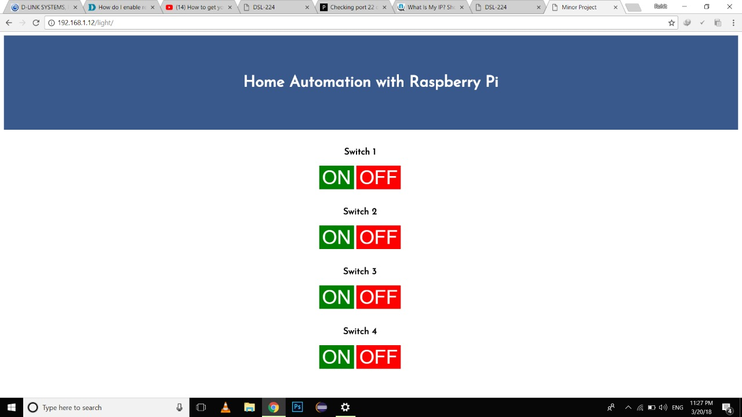

Figure 7: The web interface of the Control System

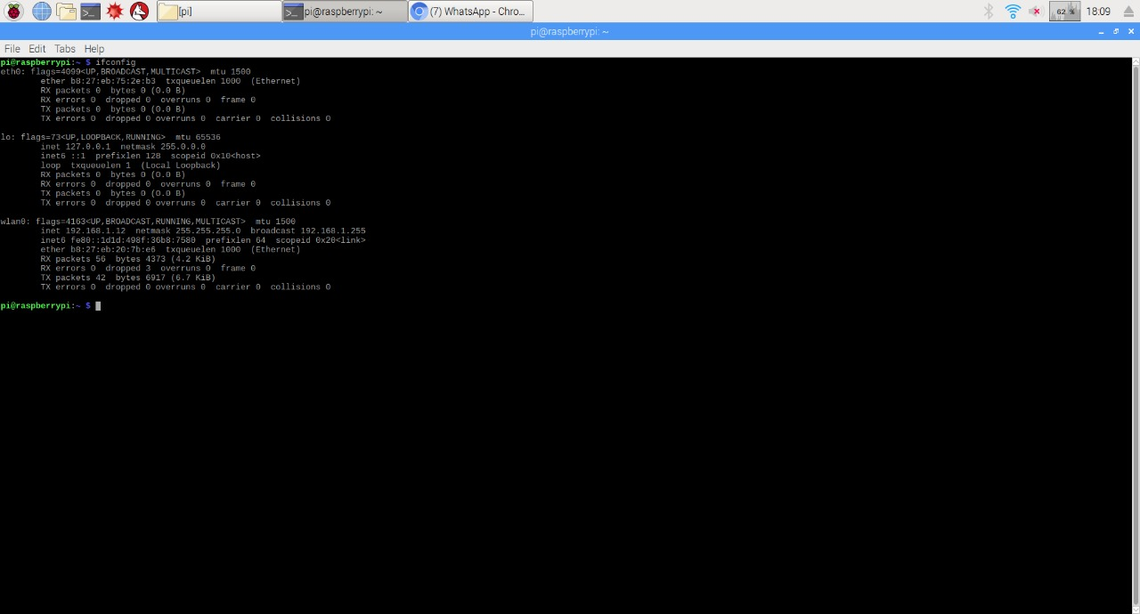

Figure 8: Raspbian Code
We use our public IP to login to the control panel remotely from any where in the world. Then, once control panel loads, we can give various commands to the Raspberry Pi to control our appliances. For every response given by user, an opposite response regarding the status of the particular appliance will be given back by the web app. Figure 6 Gives the detailed view of the case.

TEST CASE 1:
Hardware is tested in this case. That is Raspberry Pi, Appliances and other functional hardware devices in the process. This will give us an idea regarding the hardware status.
In this test case we ON/OFF the appliances to check if they are working with manual control.
Then Raspberry Pi is checked with all the physical connections with the relay board.
Relay boards manual status is also checked using Arduino.

TEST CASE 2:
Software is tested in this case. This provides us the software status of the process i.e, Whether the Raspberry Pi software configuration is proper or not.
Then whether the terminal is given the root access or not.All these tests the software stability of the process. Figure 7 provides the details regarding this test case.

TEST CASE 3:
Once Software and Hardware testing is done. We go for testing the Networking part of the process. Which is the major part of process. So, this consists of checking whether the Modem/Server is having the remote access property rightly configured. This provides the link between the world and the Raspberry Pi.

Statistics for Home Automation

ADVANTAGES
- Low cost and expandable allowing a variety of devices to be controlled
- Saves money and energy
- All in one user friendly system
- This system contain Raspberry pi as a controller so the system contain all the advantages of it.
- This is noise free system.

LIMITATIONS

- Human error
- Reliability

7.APPLICATION:

The process of controlling various operating equipment, machinery, factory operations, etc., automatically (sometimes remotely) using control systems can be termed as automation.

Automation is an efficient method to use in every field such that to reduce manpower, energy usage and also for improving the quality and efficiency of any system.

There are various emerging automation applications and a few can be listed as home automation system, industrial automation system, automated mining system, automated waste management system and so on.

By the rapid developments of new technologies, monitoring, controlling services have been started to be served along with internet as an instrument providing interaction with machinery and devices. The system can be use in several places like banks, hospital, labs and other sophisticated automated system, which dramatically reduced the hazards of unauthorized entry.

8. CONCLUSION

The goal of the paper was to design a home automated system using Raspberry pi.
So, as to help people to easily Operate the home appliances. This project is based on
the Raspberry pi, and the language used for communication of kit is Python. These
platforms are Free Open Source Software. So the overall implementation cost is low
and can be easily configured.

We are implementing smart home ideas interfacing it with the kit and making Home
to perform automated Operations. Which help people to easily monitor home
appliances without any learning.

Developed a comprehensive solution that provides a user friendly home automation
and security application for homes. We accomplished this through the integration of
cheap, off-the-shelf, widely available devices, interfaces and software coupled with a
user friendly interface. This work provides users with an easy to use in mobile and pc
for which they can remotely access and control their home appliances
and security.

In future we intend to provide a wireless relay connection and wireless sensors which
can be movable and can be operated and which can be used for Security in a single
system.

9. REFERENCES

- A. Z. Alkar and U. Buhur, “An internet based wireless home automation system for multifunctional devices,” IEEE Trans. Consum. Electron., vol. 51, no. 4, pp. 1169–1174, Nov. 2005.

- Acker, Robin, and Michael Massoth. "Secure ubiquitous house and facility control solution." Internet and Web Applications and Services” (ICIW), 2010 Fifth International Conference on. IEEE, 2010.
- D. Giusto, A. Iera, G. Morabito, and L. Atzori, The Internet of Things. New York, NY: Springer New York, 2010.

- D. Norris, The Internet of Things: Do-It-Yourself at Home Projects for Arduino, Raspberry Pi and BeagleBone Black. Tab Electronics, 2015.

- Jump up Bush, Steve (25 May 2011). “Dongle computer lets kids discover programming on a TV”. Electronics Weekly. Retrieved 11 July, 2011

- Horan B. Practical Raspberry Pi. USA: Apress; 2013.

